[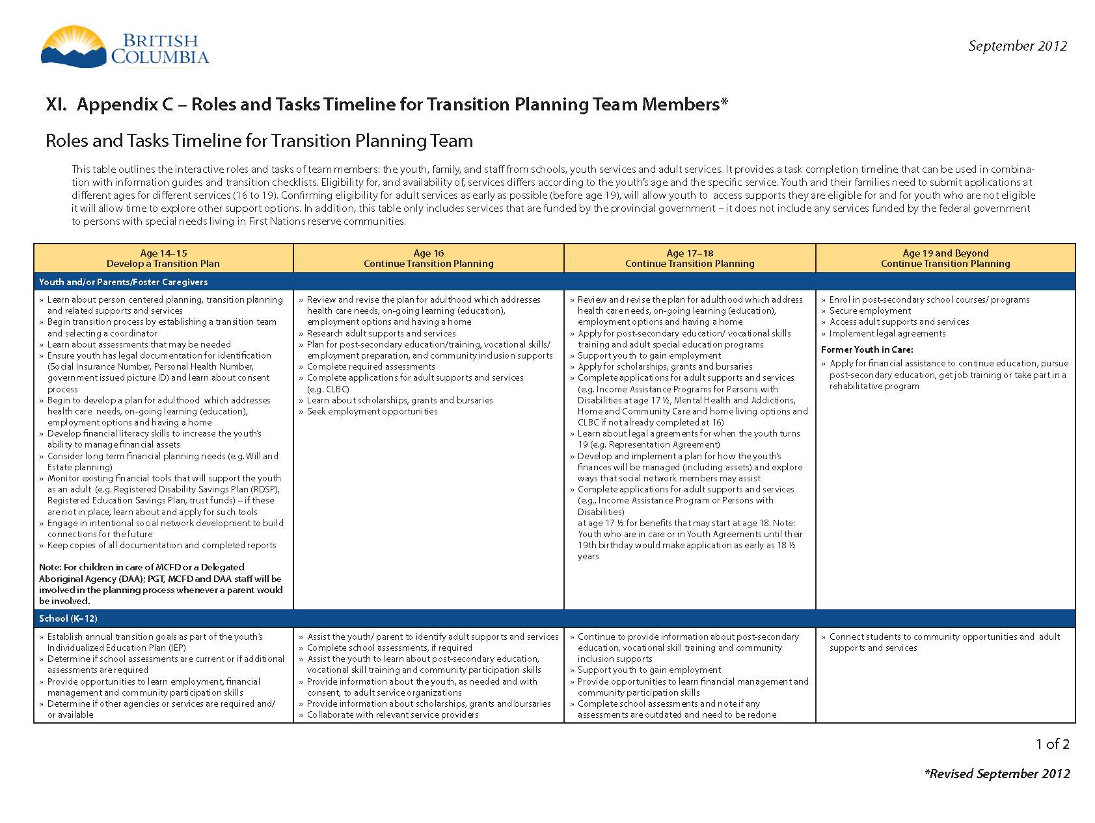](https://www.bing.com/search?q=Cross-Ministry+Transition+Planning+Protocol+for+Youth+with+Special+Needs&src=IE-SearchBox&FORM=IESR3A&DAF0=1)

[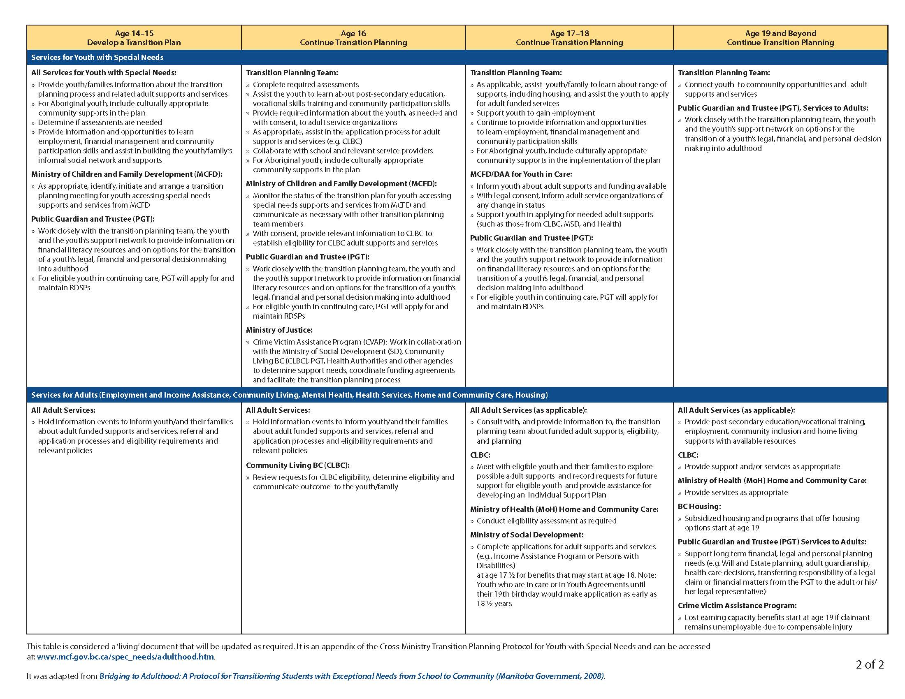](https://www2.gov.bc.ca/assets/gov/family-and-social-supports/roles_tasks_transition.pdf?bcgovtm=buffer)