Paul Gilbert’s Regulatory Systems (Learning Lab 2)

Now the Good News
The threat system is housed in our limbic system, our old brain and our reactions driven by the limbic system are automatic and primitive. Good news is that we can use our advanced brain for some good as well. When we are driven by and taken hostage (hijacked) by our limbic system, our pfc is offline. Mindfulness and CIP activate and grow the connections in your pfc. You can learn to regulate your primitive responses by using mindfulness and self compassion to soothe your emotions, bring forth calming neurochemicals, pausing and controlling your impulses (executive functions) and responding in a thoughtful, intentional way. You are strengthening your PFC and your EF by using and practicing the skills being taught in this program.

More good news. As a parent, even if you are the only person in your family learning mindfulness, by doing so you will impact your family. You will learn these skills in the program, and then as you embrace them and model them with your children and other family members, these skills may spread and strengthen the emotional regulation abilities of all family members. By helping yourself you are helping your entire family!

The Tricky Brain and its Problematic Loops: Learning Lab
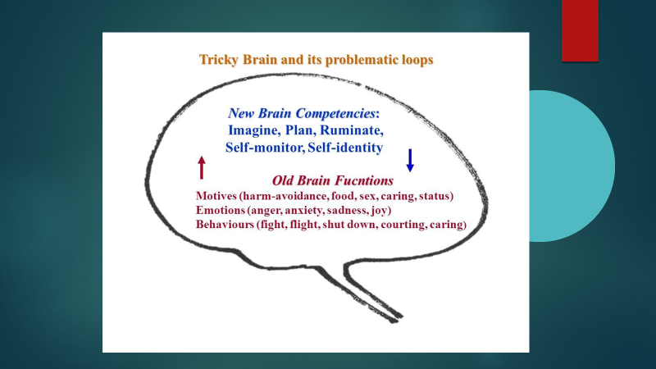

This drawing is credited to Paul Gilbert and CFT. Our old brain still exists and within it we have the three core systems that explain our motivations, and the emotions and behaviors associated with them. However, our new brain, the prefrontal cortex has evolved and allows us to imagine and problem solve and create wonderful inventions and advancements. However, those same capacities also contribute to rumination, over thinking, and excessive worry. Just as we can imagine wonderful possibilities that lead to an invention, so too can we imagine various threats and catastrophes that could occur and this heightens our threat system beyond what our original evolution intended.

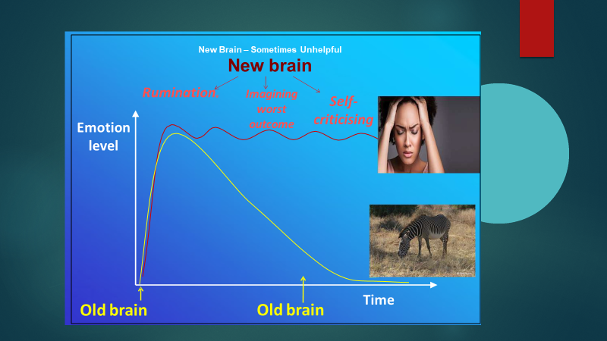

This slide (from Paul Gilbert, CFT) depicts what happened in our early human days and what still happens with most mammals in the face of threat. Consider the Zebra. He is resting and digesting, calmly eating his grass. Suddenly he sees a lion. His threat system kicks in, he runs, escapes the lion, and 5 minutes later is back to resting and digesting. The human however, sees a tiger (or some kind of threat) and quickly runs into the house to escape. The tiger disappears, however the human continues to ruminate.. Worrying if the tiger is really gone, could come back, may be lurking in the streets somewhere ready to pounce, various possibilities. Then the human criticizes herself.. Why didn’t she call the police or do something to get rid of the tiger. Now all kinds of bad things will happen because of her incompetent response… etc. etc. in any threat situation. This prolongs the amount of time spent in the threat system.

